<GGE295> METRICS REPORT

Contents

1. Project Introduction 2

2. Schedule Variance and cost Variance 2

2.1. EVMS CHART 2

2.2. EVMS Data 2

2.3. Causal Analysis(Phase wise) 4

2.4. Corrective Actions 5

3. Product Defect Density 5

3.1. Corrective Actions 5

3.2. Root Cause Analysis 5

4. Project’s Process Defect Density 7

4.1. Corrective Actions 7

4.2. Root Cause Analysis 7

# Project Introduction

Project Manager: Sobhag Prajapat

Team Size :10 Nos

# Schedule Variance and cost Variance

## EVMS CHART

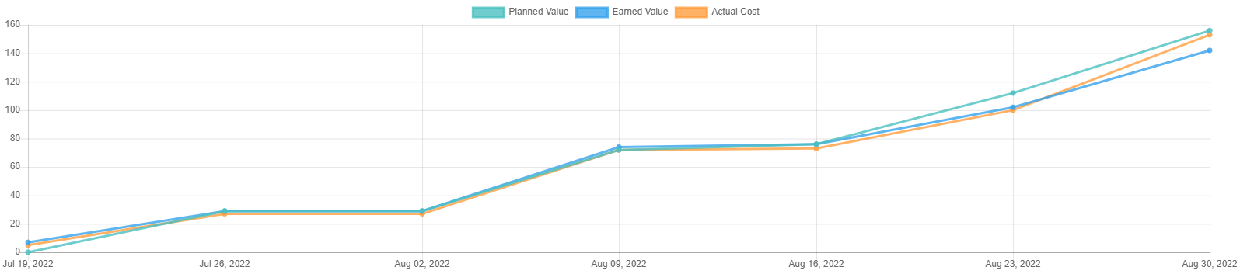

## EVMS Data

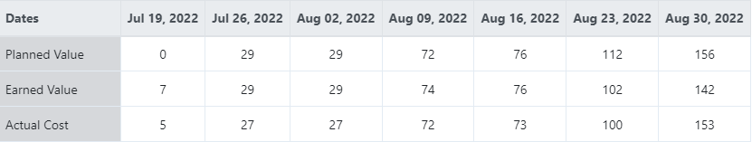

**Schedule and Cost Variance analysis at project Level**

|  |  |  |  |  |  |  |  |
| --- | --- | --- | --- | --- | --- | --- | --- |
| Weeks | No of Week | Name of Phase | Planned Value | Earned Value | Actual Cost | Schedule variance  (EV-PV/PV)*100 | Cost Variance  (AC-EV/EV)*100 |
| 1st | 19-07-22 to 26-07-22 | RD Phase, Planning Phase | 29 | 29 | 27 | 0% | -6.89% |
| 2nd | 26-07-22 to 02-08-22 | Planning Phase | 29 | 29 | 27 | 0% | -6.89% |
| 3rd | 02-08-22 to 09-08-22 | Design and Implementation | 72 | 74 | 72 | 2.77% | -2.70% |
| 4th | 09-08-22 to 16-08-22 | Testing and integration | 76 | 76 | 73 | 0% | -3.94% |
| 5th | 16-08-22 to 23-08-22 | Testing and integration | 112 | 102 | 100 | -8.9% | -1.96% |
| 6th | 23-08-22 to 30-08-22 | Validation Phase , Closure | 156 | 142 | 153 | -8.97% | 7.74% |

**Schedule and Effort Variance analysis at Weekly time slot with phase wise**

|  |  |  |  |  |  |  |  |
| --- | --- | --- | --- | --- | --- | --- | --- |
| Weeks | No of Week | Name of Phase | Planned Value | Earned Value | Actual Cost | Schedule variance  (EV-PV/PV)*100 | Cost Variance  (AC-EV/EV)*100 |
| 1st | 19-07-22 to 26-07-22 | RD Phase, Planning Phase | 29 | 29 | 27 | 0% | -6.8% |
| 2nd | 26-07-22 to 02-08-22 | Planning Phase | 0 | 0 | 0 | 0% | 0% |
| 3rd | 02-08-22 to 09-08-22 | Design and Implementation | 43 | 45 | 45 | 4.65% | 0% |
| 4th | 09-08-22 to 16-08-22 | Testing and integration | 4 | 2 | 1 | -50% | -50% |
| 5th | 16-08-22 to 23-08-22 | Testing and integration | 36 | 26 | 27 | -27.77% | 3.84% |
| 6th | 23-08-22 to 30-08-22 | Validation Phase , Closure | 44 | 40 | 53 | -9.09% | 32.5% |

## Causal Analysis(Phase wise)

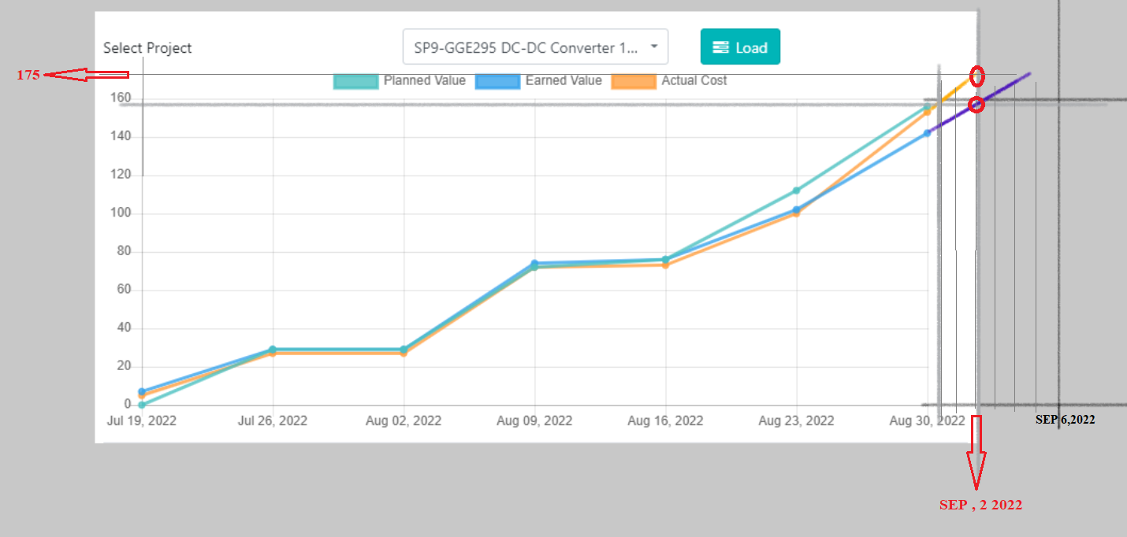

**Schedule and Effort Variance analysis at project Level**

|  |  |  |  |  |  |  |  |
| --- | --- | --- | --- | --- | --- | --- | --- |
| Weeks | No of Week | Name of Phase | Planned Value | Earned Value | Actual Cost | Schedule variance  (PV-EV/PV)*100 | Cost Variance  (EV-AC/EV)*100 |
| 1st | 19-07-22 to 26-07-22 | RD Phase, Planning Phase | 29 | 29 | 27 | 0% | -6.89% |
| 2nd | 26-07-22 to 02-08-22 | Planning Phase | 29 | 29 | 27 | 0% | -6.89% |
| 3rd | 02-08-22 to 09-08-22 | Design and Implementation | 72 | 74 | 72 | 2.77% | -2.70% |
| 4th | 09-08-22 to 16-08-22 | Testing and integration | 76 | 76 | 73 | 0% | -3.94% |
| 5th | 16-08-22 to 23-08-22 | Testing and integration | 112 | 102 | 100 | -8.9% | -1.96% |
| 6th | 23-08-22 to 30-08-22 | Validation Phase , Closure | 156 | 142 | 153 | -8.97% | 7.74% |
| 7th | 30-8-22 to 3-09-22 | Closure | 156 | 156 | 175 | 0% | 12.17% |

The schedule variance found -8.97% in negative side , we will achieve target of this phase after time and got variance in under limit.

The Cost variance found 12.1% in positive side , we will achieve target in 175 person hours after the schedule time and got variance in under limit.

## Corrective Actions

Not Required.

**The overall schedule variance : As total planned value was 156 at on date 31 Aug 2022 and we will cover up to 2 Sep. so overall schedule variance is -8.97%%, which is under limit of our measurement goal.**

**The overall cost variance : As total planned value was 156 at on date 31 Aug 2022 and we will cover it up to 175. so overall cost variance is 12.17%, which is under limit of our measurement goal.**

# Product Defect Density

The product defect density found 0.038, whereas measurement goal was 0.10±0.02. So it is little bit out of limit in lower side. The total efforts expended on this project is 157 person hrs. This means that in every 26 person hrs one functional defect came in this project.

## Corrective Actions

As this defect density documented during closure after validation so correction actions not applicable for this particular project, but may help to future projects. But I monitored the defect density during thorough life cycle, and did defect analysis 2 times, as after validation, most of the defects observed during Testing . And also previous project learning helped in this project. Now as organization goal decided for product defect density as 0.10±0.02, and my product defect density came in this range, so I’ll continue this in next projects also.

## Root Cause Analysis

The most defects observed during review of work products like functional specification, project plan, system test cases etc. The root cause analysis done for that refer below table

|  |  |  |  |  |  |
| --- | --- | --- | --- | --- | --- |
| Defect Found using | Artefact / Work Product & Version Number | Description of Defect | Summary of Resolution Steps | Analysis | Action |
| Validation | System test case ID 6 and 11 | Supply series diode getting very hot and burnt | Diode is getting hot due to use of 1000V in Place of 100V so drop voltage is higher side. so diode is replaced by 100 SMB package whose PIV is100V and current rating is 1A | Diode is getting hot due to use of 1000V in Place of 100V so drop voltage is higher side. so diode is replaced by 100 SMB package whose PIV is100V and current rating is 1A | always choose the diode ration approx. maximum absolute value with 25% extra |
| Validation | System test case ID 6 and 11 | at full capacity load 10 A Encloser getting hot and reach up to 80 Deg C | Asynchronous type DC-Dc converter always have issues with the diode drop heating . we have to use this topology with proper heat management and with use of Schottky type diode. | Asynchronous type DC-Dc converter always have issues with the diode drop heating . we have to use this topology with proper heat management and with use of Schottky type diode. | Asynchronous type Buck always have issues with the diode heating due to voltage drop . so its very compulsory during design to check the diode selection criteria |

# Project’s Process Defect Density

The process defect density found 0.22, whereas measurement goal was 0.20±0.03. So it is equal to limit. The total efforts expended on this project is 157 persons hrs. This means that in every 4.48 person hrs one major non conformance came in this project. That is equal to expected.

## Corrective Actions

As this defect density documented during closure so corrective actions not applicable for this particular project, but may help to future projects. But in this project I monitored the process defect density, and try to not leave any blunder in process point of view, as previous project leanings also use full. During updation of RTT ensure that each and every needs track by something in design, implementation, testing, no any system test case id missing to link with needs. Now as organization goal decided for process defect density as 0.20±0.02, so in next project will plan accordingly.

## Root Cause Analysis

Most of NCs main cause observed is negligence during planning upgradation, time sheet missing, negligence during RTT upgradation, so some of silly mistakes done, which actually effects more.

**Date :**

[31/08/2022]